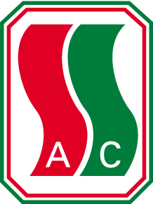

The South Side Athletic Club Alumni is committed to assisting student athletes as they pursue their education while participating in sport. We are offering a number of $1,000.00 SSAC Alumni Scholarships to student athletes who live on the south side and are graduating from an Edmonton High School.
To qualify For the SSAC Alumni Scholarship a student must:
- Permanently reside south of the North Saskatchewan River in the City of Edmonton.
- Graduate from Grade 12 in June
- Be registered to attend a post-secondary educational institution located in Edmonton as a full time student in September
- Participate in a school or community or club sport during his/her Grade 12 year
- Continue to participate in sport or maintain an active lifestyle as they continue their education

A complete application will include:
- A completed application form
- A letter of support regarding your athletic activities from your coach
- A letter of support regarding your academic commitment from a teacher
- A one page essay on how sport has enriched your high school experience

Applications will be considered and the Scholarships will be awarded according to:
- Your involvement and commitment to your sport
- Your involvement and commitment to your academic pursuits
- Your contributions in terms of “giving back” to your sport
- Your apparent financial need as you pursue your education

Completed applications are to be submitted to your school’s scholarship coordinator by

Monday May 3, 2021

Scholarship recipients will be contacted by their school. If you have any questions, please direct them to your school’s scholarship coordinator.

